陕西省西安植物园“2016年青年植物学者研讨会”
暨陕西省“丝绸之路青年学者论坛”分会场
‘Young Botanist Symposium 2016’in Xi'an Botanical Garden, Shaanxi Province
& Parallel Session of ‘Shaanxi Silk Road Young Scholar Forum’
2016年12月20-22日，西安
December 20-22, 2016, Xi'an
一、 研讨会简介
I. Brief Introduction of Symposium
“2016年青年植物学者研讨会”是陕西省首届“丝绸之路青年学者论坛”的分会场，旨在为国内外优秀青年学者搭建一个深入交流的平台，营造思想碰撞、学术争鸣的良好氛围，促进来访学者与植物园相关学科研究人员建立起实质性的联系与合作，同时为西安植物园新区建设和发展提出宝贵意见。也使与会学者深入了解国家西部战略，了解陕西省情省貌及西安市建设生态文明城市发展动态，使有意加盟的杰出人才成为西安植物园科研队伍的新鲜血液。
‘Young Botanist Symposium 2016’is the parallel session of the first ‘Silk Road Young Scholar Forum’ in Shaanxi. It aims to build a platform for in-depth exchanges among outstanding young scholars at home and abroad, create a good atmosphere of thought collision and academic contention, promote the visiting scholars to establish substantive contacts and cooperation with botanical garden-related disciplines and researchers, and to put forward valuable advice on the construction and development of new area of Xi’an Botanical Garden.In this way, the participating scholars will have a deep understanding of the strategy of developing western China, and of the situation of Shaanxi province and the development of ecological civilization in Xi'an, thus making the prominent talents freshen up scientific research team of Xi'an Botanical Garden.
陕西省西安植物园是省属科学研究事业单位，隶属陕西省科学院，主要以国家及陕西省对植物资源保护及生态环境建设的重大需求为牵引，重点开展野生植物资源研究、珍稀濒危植物迁地保育、经济植物引种驯化与开发利用、城市景观生态及环境构建、环境教育与科学普及等基础和应用基础研究，是陕西省珍稀濒危植物迁地保育基地、植物种质资源战略保存库和科普教育基地。
Xi'an Botanical Garden in Shaanxi Province is a provincial scientific research institution under the jurisdiction of Shaanxi Provincial Academy of Sciences. It mainly focuses on the dramatic demand for the plants resources protection and ecological environment construction in the country as well as in Shaanxi Province, and attaches much importance to the basic and applied basic research such as the research of wild plant resources, ex-situ conservation measures of rare and endangered plants, introduction and acclimatization as well as the exploitation and utilization of economic plants, the ecology and environment construction of urban landscape and environment education and science popularization. It represents the ex-situ conservation base for rare and endangered plants in Shaanxi Province, the preservation base of plant germplasm resource strategy and popular science education base.
陕西省西安植物园现诚邀全球杰出青年人才汇聚于古城西安（2016年12月20日-22日），就相关领域的前沿科技热点问题及个人成长成才、职业发展开展讨论。
Xi’an Botanical Garden in Shaanxi Province now invites the outstanding young elites all around the world to gather together in the ancient city - Xi’an on December 20 to December 22, 2016, and have in-depth discussions in the issues like the cutting-edge scientific and technological in the relevant fields, personal growth and career development.
研讨会主题为“植物传播与技术创新”，围绕生物科学、园林园艺等学科领域，聚焦植物传播过程中对世界社会经济发展的贡献，就丝绸之路东西方科学技术发展、植物及文化交流、汉唐园林景观对世界的影响、中国在生物科学领域对世界的贡献及发展开展讨论。
‘Plant Spread and Technological Innovation’ is the theme of symposium. It centers on the biological sciences, garden horticulture and other disciplines, focuses on plant spread’s contribution to world's social and economic development, and have discussion in the issues like the development of science and technology between the East and the West along the Silk Road, plant and cultural exchanges, the impacts of landscapes in Han and Tang dynasties on the world, China's contribution to the world in the field of biological science.
研讨会面向以下学科领域的海内外青年学者：
The symposium is open to young scholars at home and abroad who are interested in the following disciplines:
(1)植物学；(2)生态学；(3)土壤学；(4)农艺学；
(1) Botany;(2) Ecology; (3) Agrology; (4) Agronomy;
(5)园林、园艺学；(6)遗传学、分子育种学。
(5) Garden, horticulture; (6) Genetics, molecular breeding science.
二、 申请条件
II. Application Conditions
申请人具有博士学位，年龄40周岁以下，具有2年以上科研或工作经历。
The applicant should have a doctoral degree, at the age of 40 and below, with more than 2 years of scientific research or work experience.
申请人在所从事领域已取得突出的学术业绩，为同龄人中的拔尖人才，已获得学术界同行的高度认可。
The applicant should have made an outstanding academic performance in his or her own field, and be the top-notch talent among peers who have been highly recognized by fellow academics.
申请人具有广阔的学术视野和创新思维，具备成为所从事领域领军人才的潜质。
The applicant should have a broad academic vision and innovative thinking, and have the potential to be the leading personnel in his or her own field.
申请人学风严谨，遵守法纪及职业道德规范。
The applicant should have rigorous scholarship and abide by the law and professional ethics.
三、 注册申请
III. Application for Registration
方式1：在线注册（网址：sczl.xazwy.com）
Option 1: Registration online (website: sczl.xazwy.com)
申请人填写下方会议注册表并将个人简历发送到会务组邮箱。简历应包括个人基本信息（含教育、工作经历），研究兴趣、学术业绩介绍（含论文清单）、以及其他申请人认为必要的内容。简历以word或PDF格式发送，中文、英文均可。
Applicants should fill in the registration form below and send to the Seminar Group Email. The curriculum vitae should include the following information: basic personal information (including education, work experience), research interests, academic performance presentations (including the list of papers), and other contents deemed necessary by the applicants. All these materials should be uploaded in word or PDF format. Both Chinese and English resumes are acceptable.
方式2：邮箱报名
Option 2: Mailbox registration
申请人将个人信息及简历发送至会务组邮箱：sxxabg@163.com。个人信息应包含：姓名、性别、出生年月、Email、现供职国家或地区、现供职单位、中国大陆手机号码(如有)。
Applicants should send their personal information and resume to the Seminar Group Email: sxxabg@163.com. Personal information should include: name, gender, date of birth, Email, in- service country or region, in-service unit, China Mobile phone number (if any).
申请截止日期：2016年11月30日。
Application deadline: November 30, 2016.
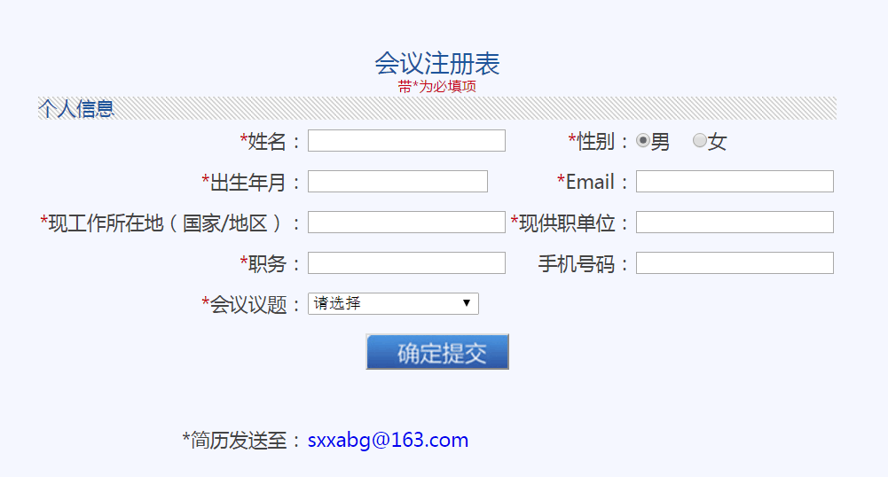
Conference Registration Form
* is the must-filling item
Personal information
*Name |  | *Gender: | Male Female
*Date of birth |  | *Email:
*In-service country or region |  | *In-service unit
*Position |  | Mobile number
*Agenda item (please select)
Confirm to submit
*Send resume to: sxxabg@163.com
注册重要提示:
Important Notes for Registration:
1. 注册邮箱是会务组的首选联系途径，注册成功确认、审核结果通知、邀请函发送及访问相关信息均将发送至您填写的注册邮箱，请务必确保邮箱地址拼写正确，并尽量避免使用Gmail、Hotmail或后缀名称太复杂的邮箱地址，以免出现会务组邮件被屏蔽或投至垃圾邮件箱等情况。
Registered email is the preferred way to contact the seminar group. Registration confirmation, notification of audit result, invitations and access information shall be sent to your registered email. Please make sure your email address is spelled correctly and try to avoid using Gmail, Hotmail or e-mail address with too complex suffix name, in order to avoid that the seminar group mail is blocked or cast to the spam box and so on.
2. 在线注册成功后，您的注册邮箱将即时收到注册成功确认信，如未收到，请尝试再次注册或与会务组秘书处联系确认（电话:+8629 85251750）。
If your registration is successful, you will receive a registration confirmation immediately. If you do not receive the registration confirmation, please try to register again or contact the seminar secretariat (Tel: +8629 85251750).
3. 邮箱报名后，会务组1～3个工作日为您完成在线注册，注册成功后，您的报名邮箱将及时收到注册成功确认信。
After the registration, the seminar group needs 1 to 3 working day(s) to complete the online registration for you. If your registration is successful, your registered email will receive a registration confirmation letter.
4. 如注册完成后需要更改注册信息或更新简历，请重新注册，会务组将以最新的注册信息为准。
If you need to change the registration information or update your resume after registration, please register again. The latest registration information shall prevail.
四、 日程安排
IV. Schedule
日期  Date | 时间  Time |  | 内容  Contents | 参加人  Participants | 地点  Place
12月20日（周二）  December 20 (Tuesday) | 会议报到  Conference Registration
12月20日（周二）  December 20 (Tuesday) | 全天  Full day | 签到、入住及差旅费报销  Sign in, check-in and travel reimbursement |  | 来访学者  Visiting scholars | 百事特威酒店  Best Western Bestwy Hotel
12月21日（周三）  December 21 (Wednesday  ) | 7:30-8:20 | 早餐  Breakfast |  | 来访学者  Visiting scholars | 百事特威酒店茉莉餐厅  Jasmine Restaurant, Best Western Bestwy Hotel
12月21日（周三）  December 21 (Wednesday  ) | 陕西省主论坛  The main forum, Shaanxi Province
12月21日（周三）  December 21 (Wednesday  ) | 8:20-8:50 | 集体乘车  Bus ride |  | 来访学者  Visiting scholars | 百事特威酒店  Best Western Bestwy Hotel
12月21日（周三）  December 21 (Wednesday  ) | 9:00-12:00 | 参加陕西省“丝绸之路青年学者论坛”主论坛  Shaanxi ‘Silk Road Young Scholar Forum’ |  | 陕西省委、省政府、各分论坛开办单位及各分论坛来访学者  Shaanxi Provincial Party Committee, the provincial government, the organization unit of sub-forum and visiting scholars from sub-forums | 待定  To be determined
12月21日（周三）  December 21 (Wednesday  ) | 12:00-12:30 | 集体乘车返回植物园  Bus ride back to the botanical garden |  | 来访学者  Visiting scholars | 待定  To be determined
12月21日（周三）  December 21 (Wednesday  ) | 12:30-14:30 | 午餐及休息  Lunch and break |  |  | 百事特威酒店茉莉餐厅  Jasmine Restaurant, Best Western Bestwy Hotel
12月21日（周三）  December 21 (Wednesday  ) | 2016年青年植物学者研讨会  Young Botanist Symposium 2016
12月21日（周三）  December 21 (Wednesday  ) | 14:30-15:00 | 中科院西安分院领导致辞  Leader of Xi'an Branch of Chinese Academy of Sciences delivers the speech |  | 来访学者、上级领导、相关职能部门负责人、中科院西安分院各院所代表  Visiting Scholars, Senior Leaders, Head of relevant functional departments, Representative Office of Xi'an Branch of Chinese Academy of Sciences | 植物园学术报告厅  Lecture Hall of Botanical Garden
12月21日（周三）  December 21 (Wednesday  ) | 15:00-16:00 | 西安植物园主任介绍植物园新区建设及发展  Director of Xi'an Botanical Garden introduces the construction and development of New Area of Botanic Garden |  |  | 植物园学术报告厅  Lecture Hall of Botanical Garden
12月21日（周三）  December 21 (Wednesday  ) | 16:00-16:20 | 休息  Break |  |  | 植物园学术报告厅  Lecture Hall of Botanical Garden
12月21日（周三）  December 21 (Wednesday  ) | 16:20-17:20 | “丝绸之路植物与文化”主题报告  Thematic Report of “Plant and Culture along the Silk Road” |  |  | 植物园学术报告厅  Lecture Hall of Botanical Garden
12月21日（周三）  December 21 (Wednesday  ) | 17:20-18.00 | “中西方植物交流对世界经济社会的贡献”  ‘The Contribution of Plant Exchange between China and the West to the World Economy and Society’ |  |  | 植物园学术报告厅  Lecture Hall of Botanical Garden
12月21日（周三）  December 21 (Wednesday  ) | 18:10-19:30 | 晚餐  Dinner |  |  | 百事特威酒店茉莉餐厅  Jasmine Restaurant, Best Western Bestwy Hotel
12月22日（周四）  December 22(Thursday) | 7:30-8:20 | 早餐  Breakfast |  | 来访学者  Visiting scholars | 百事特威酒店茉莉餐厅  Jasmine Restaurant, Best Western Bestwy Hotel
12月22日（周四）  December 22(Thursday) | 8:30-12:00 | 来访学者学术报告  Visiting Scholar Academic Report |  | 来访学者及西安植物园科研人员  Visiting Scholar and Scientific Researchers of Xi'an Botanical Garden | 西安植物园学术报告厅  Lecture Hall of Xi’an Botanical Garden
12月22日（周四）  December 22(Thursday) | 12:00-14:30 | 午餐及休息  Lunch and break |  |  | 百事特威酒店茉莉餐厅  Jasmine Restaurant, Best Western Bestwy Hotel
12月22日（周四）  December 22(Thursday) | 14:30-15:00 | 集体乘车参观西安植物园专类园区  Bus ride to visit the Special Garden in Xi'an Botanical Garden |  |  | 西安植物园大门口  Entrance of Xi'an Botanical Garden
12月22日（周四）  December 22(Thursday) | 15:00-16:30 | 参观新区  Visit New Area
12月22日（周四）  December 22(Thursday) | 16:30-18:00 | 交流讨论  Communication and Discussion |  |  | 西安植物园新区报告厅  Lecture Hall of New Area in Xi’an Botanical Garden
12月22日（周四）  December 22(Thursday) | 18:00-18:30 | 集体乘车返回酒店  Bus ride back to the hotel |  |  | 西安植物园新区西大门  West Gate of New Area in Xi'an Botanical Garden
12月22日（周四）  December 22(Thursday) | 18:30-19:30 | 晚餐  Dinner |  | 来访学者  Visiting scholars | 百事特威酒店茉莉餐厅  Jasmine Restaurant, Best Western Bestwy Hotel
五、 其它信息
V. Additional Information
本次会议会务组统一安排食宿及会期用车，不收取费用，为参会专家学者报销往返国际国内旅费（受邀学者在收到正式邀请函之后，请自行规划行程并垫付购票费用）。
Meeting group will provide unified arrangements for the free accommodation and car using; reimburse the participants (experts and scholars) for the international and domestic travel expenses (invited scholars should start planning their own itineraries, book air tickets and pay the fees in advance after receiving the formal invitation letter).
六、 联系方式
VI. Contact Us
“2016年青年植物学者研讨会”会务组
‘Young Botanist Symposium 2016’Seminar Group
报名联系人：李鑫Contact for registration: Li Xin
电话：+8629—85251750
Tel: +8629 - 85251750
邮箱：sxxabg@163.com
E-mail: sxxabg@163.com

